SPIN&SPRINT PATTERN PROBLEMS(1ST YRS)
- Input value n=5

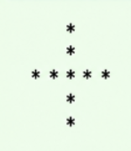

2. Input value n=4

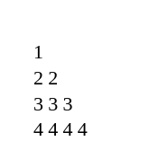

3.input value n=5



4. Input value n= 5

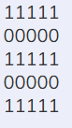

5. Input value n=5
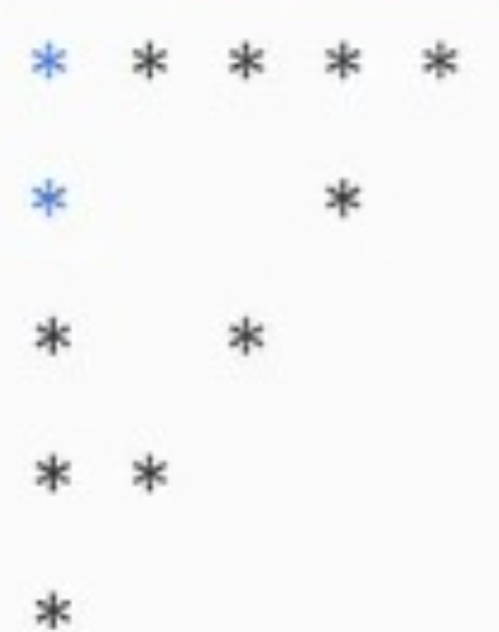

6. Input value n=4

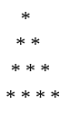

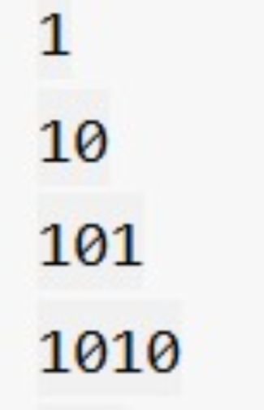
7. Input value n=4

8. Input value n=5



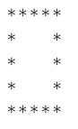
9. Input value n=5

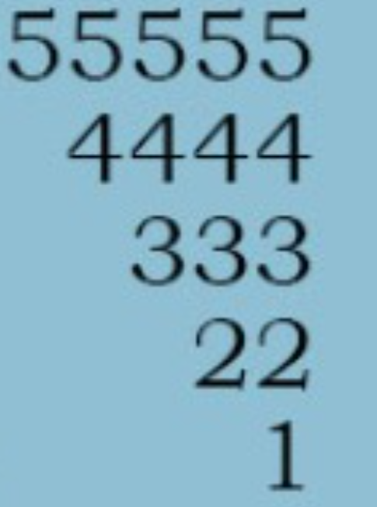
10. Input value n=5

PROGRAMMING PROBLEMS

1.WRITE A PROGRAM TO READ A GIVEN STRING AND PRINT IT IN REVERSE ORDER.

2. WRITE A PROGRAM TO PRINT THE MULTIPLICATION TABLE OF THE GIVEN NUMBER.

3.WRITE A PROGRAM TO CHECK IF A NUMBER IS EVEN OR ODD.

4.WRITE A PROGRAM TO CHECK IF A NUMBER IS POSITIVE,NEGATIVE, OR .ZERO.

5.WRITE A PROGRAM TO FIND THE LARGEST OF TWO NUMBERS.

6.WRITE A PROGRAM TO PRINT THE FIRST TEN NATURAL NUMBERS.

7. WRITE A PROGRAM TO FIND THE LENGTH OF THE STRING.

8. WRITE A PROGRAM TO FIND THE SMALLEST OF THREE NUMBERS.

9.WRITE A PROGRAM TO READ A TWO INTEGERS AND PRINT THEIR SUM.

10.WRITE A PROGRAM TO CHECK IF A CHARACTER IS VOWEL OR A CONSONANT.

